Amit Machine Learning Diploma

Error bars in seaborn.barplot

Name: Mahmoud Hosam Gamil Nasr

To: Eng. Ahmed Khaled

**Error bars**

It define the confidence interval and uncertainty around the estimate.

If you are using aggregated values in a barplot, error bars will give you a general idea of how precise a measurement is.

If you are using **matplot** library, you will have to use **errorbar()** function that used to plot y versus x as lines and/or markers with attached error bars.

However, in **seaborn**, the default that **barplot()** function draws error bars in the plot with 95% confidence interval.

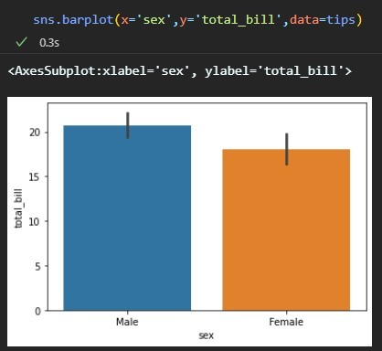

Some parameters:

**errcolor** : matplotlib color

Color for the lines that represent the confidence interval.

**errwidth** : float, optional

Thickness of error bar lines (and caps).

**capsize** : float, optional

Width of the “caps” on error bars.